HD-SDI CAT5 Extender Series
ITEM NO.: SDI05

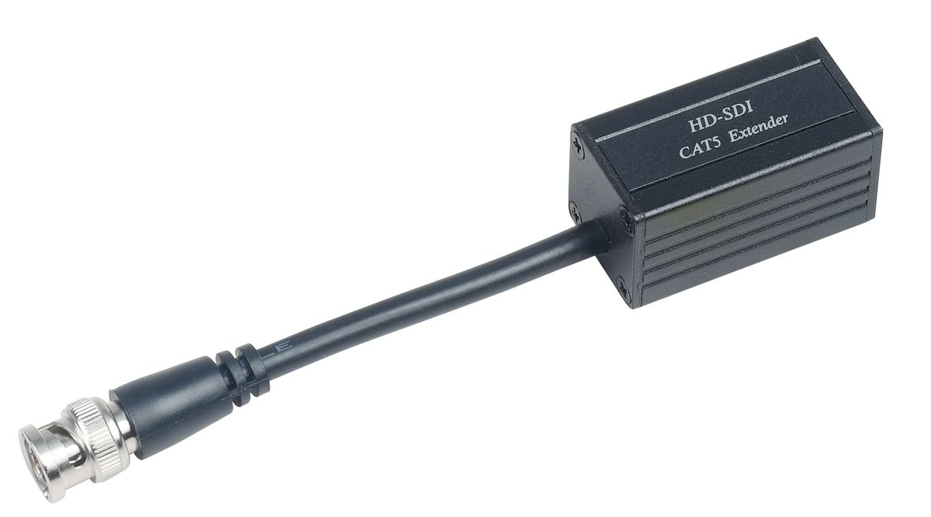
HD-SDI CAT5 Extender is a passive device which use in one pair to send HD-SDI signals up to 45m via a CAT6 cable at HD resolution in a point-to-point configuration. The HD-SDI passive CAT5 extender supports uncompressed transmission of up to 1.485G b/s. It is perfect to send HD CCTV over existing CAT5 cable Applications include HD-CCTV, broadcasting, HD camcorder, studio-to-studio, post production, live events, medical imaging displays, and medical imaging…etc.
SDI05 HD-SDI CAT5 Extender - Passive type
- To send HD SDI signal over CAT5e/6 UTP cable.
- Support SDI (SMPTE 259M), HD-SDI (SMPTE 292M)
- No external power required.
- Up to 45 meters via CAT6 cable at HD-SDI resolution.
- Up to 150M meters via CAT6 cable at SDI resolution.

Installation View:
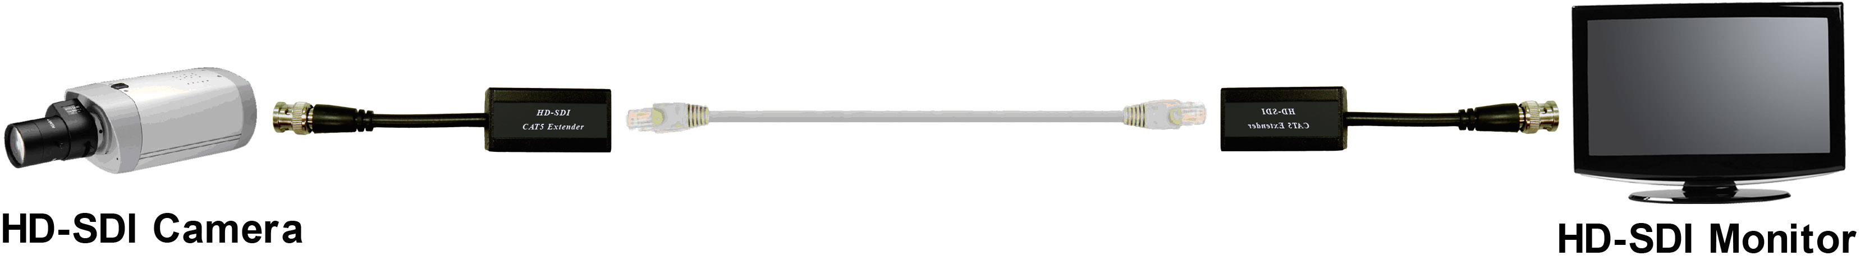

Working Distance:
Cable Max. distance | CAT5e UTP cable | CAT6 UTP cable
SD resolution (270Mbps) | 130M | 150M
HD resolution (1.45Gbps) | 30M | 45M

Recommend Cable:
Using high quality CAT5e UTP or CAT6 UTP cable

RJ45 Pin Define:
Using Standard EIA/TIA 568B

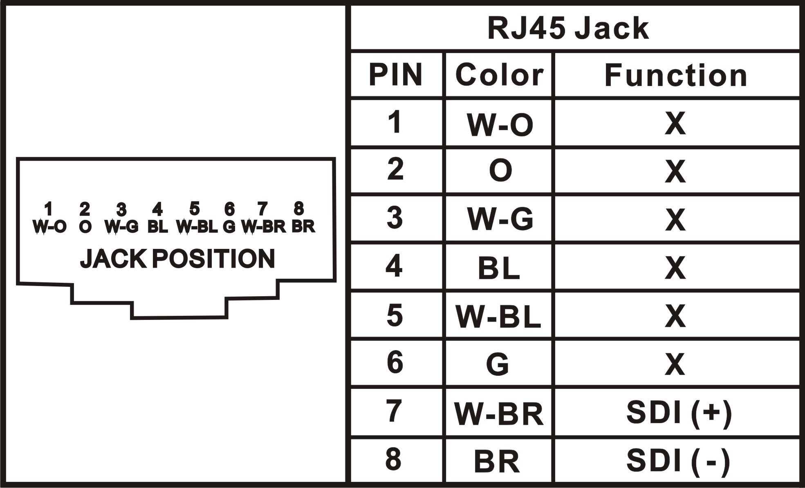

Specification:

ITEM NO | SDI05
Video | BNC x 1 (75 Ω) MALE
Transmission Interface | RJ45 x 1
RJ45 pin define | Pin 7 SDI (+)、Pin 8 SDI(-)
Insert loss | <6 dB
Video Bandwidth | 270M b/s，1.485G b/s
Transmission Distance | SD：CAT5e UTP / 130M，CAT6 UTP / 150M  HD：CAT5e UTP / 30M，CAT6 UTP / 45M
Temperature | Operation: 0 to 55℃, Storage: -20 TO 85℃, Humidity: up to 95%
Dimensions mm | 25.4 x 25.4 x 140.5 (include BNC cable 91 mm)
Weight g | 58

Rev.A

